|  |  |  |
| --- | --- | --- |
| Tybca Sem-5 Div-2 | Web Framwork Services | Roll no :- 000 |

**1. Write a python program to redirect on home page on successful login otherwise again display login.html page. Tale fix values of email id and password to match with submied values by POST method, display Email id on home page with welcome message.**

App.py:-

from flask import Flask, render_template, request, redirect, url_for app = Flask(__name__)

email_id = "test@example.com"   
password = "password123"

@app.route('/', methods=['GET', 'POST'])   
def login():   
 if request.method == 'POST':   
 submied_email = request.form['email']   
 submied_password = request.form['password']   
 if submied_email == email_id and submied_password == password: return redirect(url_for('home', email=submied_email))   
 return render_template('login.html')

@app.route('/home', methods=['GET'])   
def home():   
 email = request.args.get('email')   
 return render_template('home.html', email=email)

if __name__ == '__main__':   
 app.run(debug=True)

1

|  |  |  |
| --- | --- | --- |
| Tybca Sem-5 Div-2 | Web Framwork Services | Roll no :- 000 |

home.html :-

<h1>Welcome, {{ email }}!</h1>

Login.html :-

<form acon="" method="post">   
 <label for="email">Email:</label>   
 <input type="email" id="email" name="email"><br><br>   
 <label for="password">Password:</label>   
 <input type="password" id="password" name="password"><br><br> <input type="submit" value="Login">   
</form>

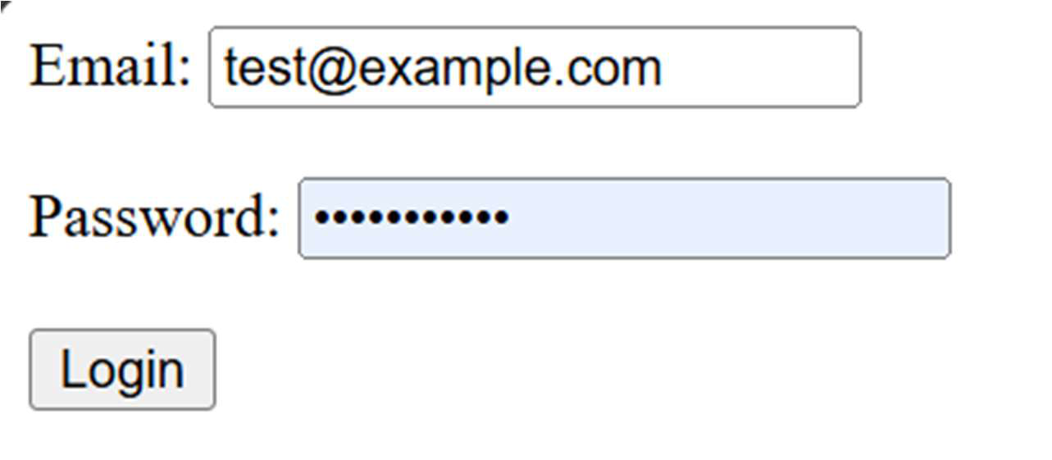



2

|  |  |  |
| --- | --- | --- |
| Tybca Sem-5 Div-2 | Web Framwork Services | Roll no :- 000 |

**2. Write a python program to display user name on home page using session, only aer successful login. Create logout link on home page to destroy session and redirect on login page.**

**App.py :-**

from flask import Flask, render_template, request, session, redirect, url_for app = Flask(__name__)

@app.route('/login', methods=['GET', 'POST'])   
def login():   
 if request.method == 'POST':   
 username = request.form['username']   
 password = request.form['password']   
 if username == 'admin' and password == 'admin':   
 session['username'] = username   
 return redirect(url_for('home'))   
 return render_template('login.html')

@app.route('/home')   
def home():   
 if 'username' in session:   
 username = session['username']   
 return render_template('home.html', username=username) return redirect(url_for('login'))

@app.route('/logout')   
def logout():   
 session.pop('username', None)   
 return redirect(url_for('login'))

if __name__ == '__main__':   
 app.run(debug=True)

3

|  |  |  |
| --- | --- | --- |
| Tybca Sem-5 Div-2 | Web Framwork Services | Roll no :- 000 |

**login.html :-**

<!DOCTYPE html>   
<html>   
 <head>   
 <tle>Login</tle>   
 </head>   
 <body>   
 <h1>Login</h1>   
 <form acon="" method="post">   
 <label for="username">Username:</label>   
 <input type="text" id="username" name="username"><br><br> <label for="password">Password:</label>   
 <input type="password" id="password" name="password"><br><br> <input type="submit" value="Login">   
 </form>   
 </body>   
</html>

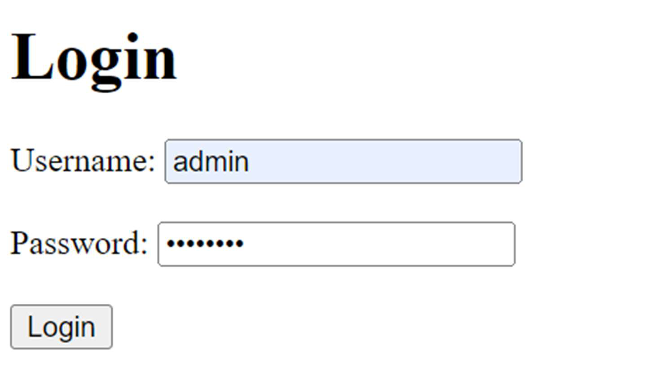

4

|  |  |  |
| --- | --- | --- |
| Tybca Sem-5 Div-2 | Web Framwork Services | Roll no :- 000 |

**Home.html :-**

<!DOCTYPE html>   
<html>   
 <head>   
 <tle>Home</tle>   
 </head>   
 <body>   
 <h1>Welcome, {{ username }}!</h1>   
 <p><a href="{{ url_for('logout') }}">Logout</a></p>   
 </body>   
</html>

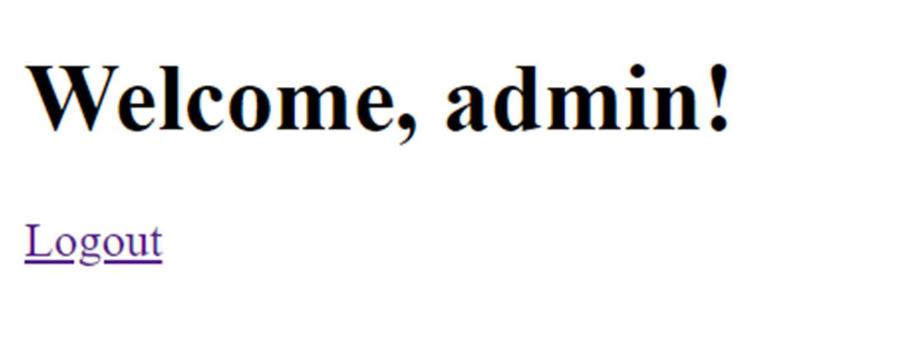

5

|  |  |  |
| --- | --- | --- |
| Tybca Sem-5 Div-2 | Web Framwork Services | Roll no :- 000 |

**3. Write a python program to display alert message given in a JavaScript funcon defined in ‘hello.js’ is called on ‘onClick’ event of HTML buon in ‘index.html’ , which is rendered on ‘/’ URL of the Flask applicaon. Use Jinja2 Syntax to take ‘hello.js’ script in ‘index.html’ page.**

**App.py :-**

from flask import Flask, render_template   
app = Flask(__name__)

@app.route('/')   
def home():   
 return render_template('index.html')

if __name__ == '__main__':   
 app.run(debug=True)

index.html :-

<!DOCTYPE html>   
<html lang="en">   
<head>   
 <tle>Flask Alert Example</tle>   
 <script src="{{ url_for('stac', filename='hello.js') }}"></script> </head>   
<body>   
 <h1>Welcome to the Flask Alert Example</h1>   
 <buon onclick="showAlert()">Click Me!</buon>   
</body>   
</html>

6

|  |  |  |
| --- | --- | --- |
| Tybca Sem-5 Div-2 | Web Framwork Services | Roll no :- 000 |

hello.js :-

funcon showAlert() {

alert("Hello! This is an alert message.");

}

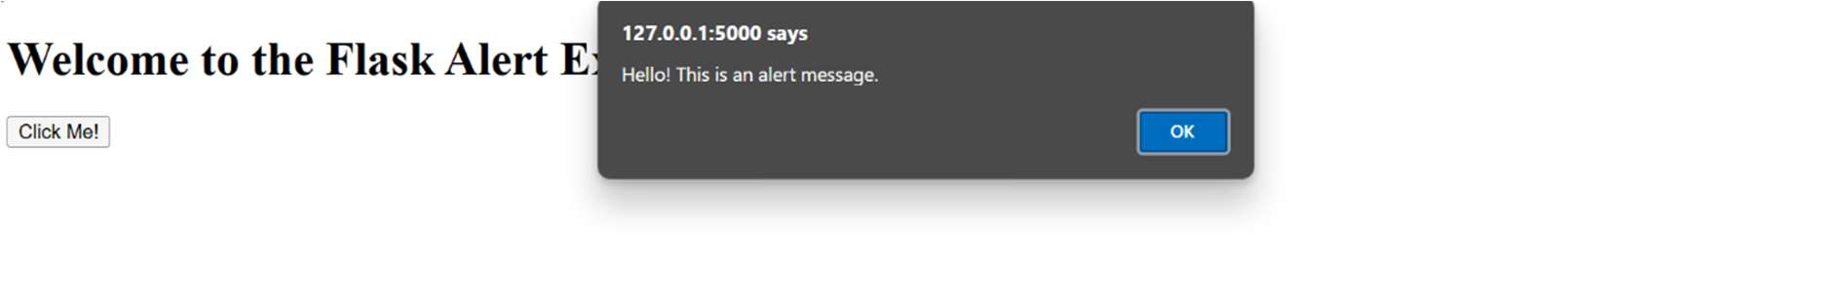



**4. Write a python program to upload and save your photo in image folder of your flask**

**app. In program check that if selected photo is of png, jpg or .jpeg type and resize must be**

**less than 50 kB then only it can upload. Also, display photo on screen aer upload.**

App.py :-

import os

from flask import Flask, request, render_template, redirect, url_for

from PIL import Image

import io

app = Flask(__name__)

# Set upload folder

UPLOAD_FOLDER = 'stac/images'

app.config['UPLOAD_FOLDER'] = UPLOAD_FOLDER

# Allowed extensions

7

|  |  |  |
| --- | --- | --- |
| Tybca Sem-5 Div-2 | Web Framwork Services | Roll no :- 000 |

ALLOWED_EXTENSIONS = {'png', 'jpg', 'jpeg'}

# Funcon to check allowed file extensions

def allowed_file(filename):

return '.' in filename and filename.rsplit('.', 1)[1].lower() in ALLOWED_EXTENSIONS

@app.route('/', methods=['GET', 'POST'])

def upload_file():

if request.method == 'POST':

if 'file' not in request.files:

return redirect(request.url)

file = request.files['file']

if file.filename == '':

return redirect(request.url)

if file and allowed_file(file.filename):

# Resize image and check size

image = Image.open(file.stream)

image.thumbnail((800, 800)) # Resize image to max 800x800

img_byte_arr = io.BytesIO()

image.save(img_byte_arr, format=image.format)

img_byte_arr.seek(0)

# Check size

if img_byte_arr.getbuffer().nbytes > 50 * 1024: # 50 KB

return "File size must be less than 50 kB", 400

# Save the image

file_path = os.path.join(app.config['UPLOAD_FOLDER'], file.filename)

image.save(file_path)

8

|  |  |  |
| --- | --- | --- |
| Tybca Sem-5 Div-2 | Web Framwork Services | Roll no :- 000 |

return render_template('upload.html', filename=file.filename)

return render_template('upload.html')

if __name__ == '__main__':   
 os.makedirs(UPLOAD_FOLDER, exist_ok=True)   
 app.run(debug=True)

upload.html :-

<!DOCTYPE html>   
<html lang="en">   
<head>   
 <meta charset="UTF-8">   
 <meta name="viewport" content="width=device-width, inial-scale=1.0"> <tle>Upload Photo</tle>   
</head>   
<body>   
 <h1>Upload a Photo</h1>   
 <form method="POST" enctype="mulpart/form-data">   
 <input type="file" name="file" required>   
 <buon type="submit">Upload</buon>   
 </form>

{% if filename %}   
 <h2>Uploaded Photo:</h2>   
 <img src="{{ url_for('stac', filename='images/' + filename) }}" alt="Uploaded Photo" style="max-width: 300px;">   
 {% endif %}   
</body>   
</html>

9

|  |  |  |
| --- | --- | --- |
| Tybca Sem-5 Div-2 | Web Framwork Services | Roll no :- 000 |

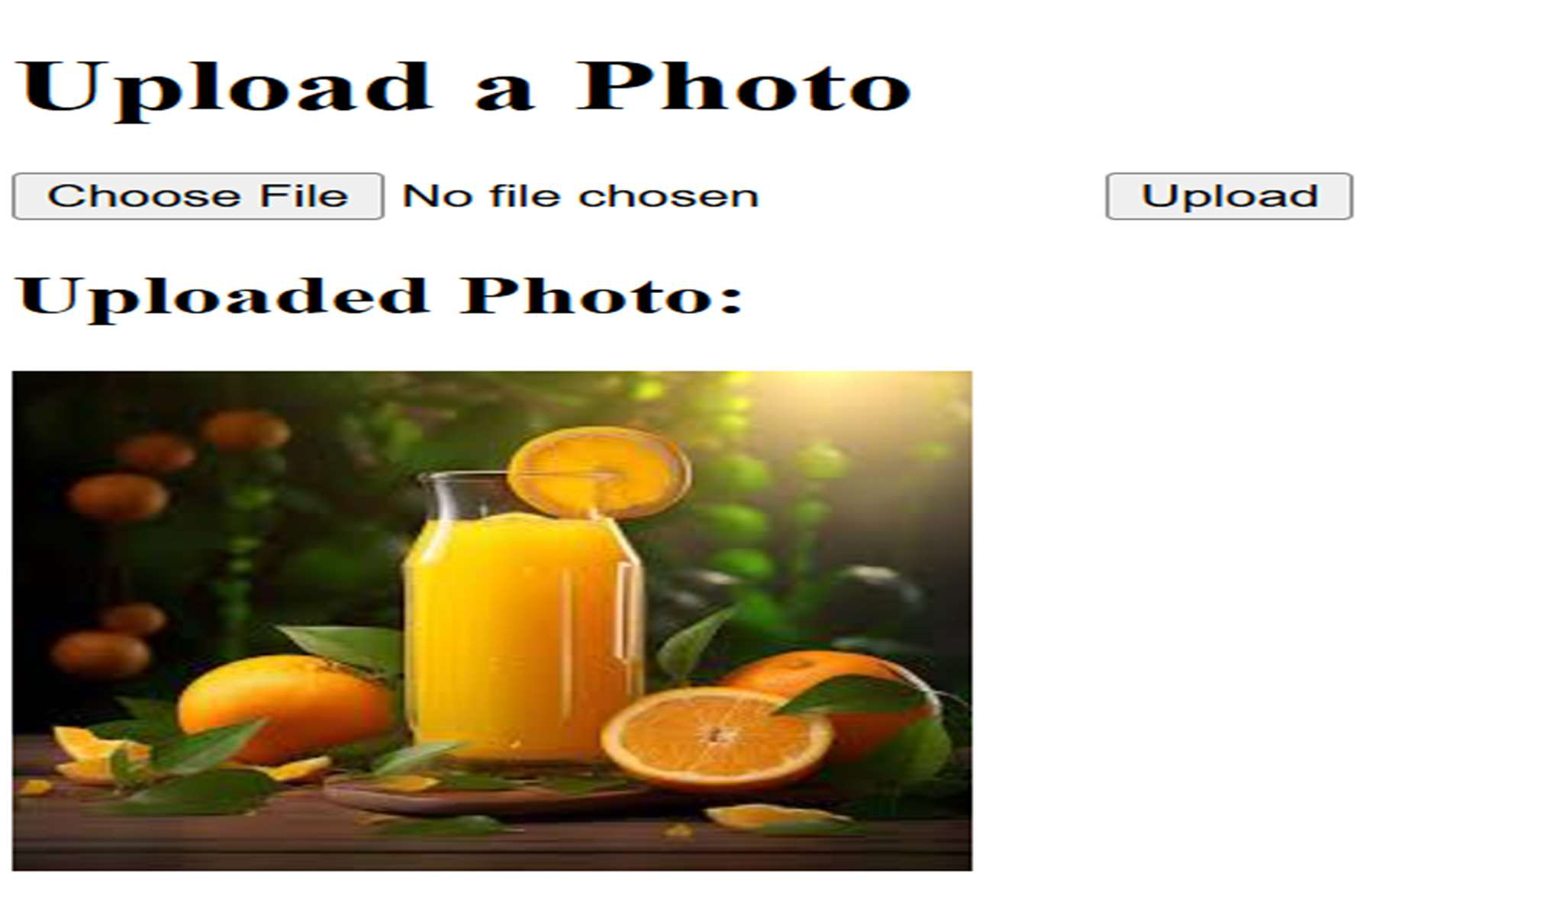

**5. Create web pages using PHP that accepts informaon of beauty products like**   
**ProductuctId, Name, Category, Descripon, Company and Price etc. Product category could be skin care, Make-up, Hair Cate, Daily Essenal and Fragrances. Provide following facilies.**

• **Insert the product informaon in the database.**

• **Update the product informaon on the basis of product id.**

• **Search the products based on the given category.**

**db.php :-**

**<?php**

**$host = "localhost";**

**$db_name = "beauty_products_db";**

**$username = "root"; // Change this if necessary**

**$password = ""; // Change this if necessary**

10

|  |  |  |
| --- | --- | --- |
| Tybca Sem-5 Div-2 | Web Framwork Services | Roll no :- 000 |

**try {**   
  **$conn = new PDO("mysql:host=$host;dbname=$db_name", $username, $password);**   **$conn->setAribute(PDO::ATTR_ERRMODE, PDO::ERRMODE_EXCEPTION);**   
**} catch(PDOExcepon $e) {**   
  **echo "Connecon failed: " . $e->getMessage();**   
**}**   
**?>**

**Insert.php :-**

**<?php**   
**include 'db.php';**

**if ($_SERVER["REQUEST_METHOD"] == "POST") {**   
 **$name = $_POST['name'];**   
 **$category = $_POST['category'];**   
 **$descripon = $_POST['descripon'];**   
 **$company = $_POST['company'];**   
 **$price = $_POST['price'];**

**$sql = "INSERT INTO products (name, category, descripon, company, price) VALUES (?, ?, ?, ?, ?)";**   
  **$stmt = $conn->prepare($sql);**   
  **$stmt->execute([$name, $category, $descripon, $company, $price]);**

**include_once 'footer.php';**

**}**

11

|  |  |  |
| --- | --- | --- |
| Tybca Sem-5 Div-2 | Web Framwork Services | Roll no :- 000 |

**?>**

**<!DOCTYPE html>**   
**<html lang="en">**   
**<head>**   
  **<meta charset="UTF-8">**   
  **<tle>Insert Product</tle>**   
**</head>**   
**<body>**   
  **<h1>Insert Beauty Product</h1>**   
  **<form method="POST" acon="">**   
  **<input type="text" name="name" placeholder="Product Name" required><br>**   **<select name="category" required>**   
  **<opon value="Skin Care">Skin Care</opon>**   
  **<opon value="Make-up">Make-up</opon>**   
  **<opon value="Hair Care">Hair Care</opon>**   
  **<opon value="Daily Essenal">Daily Essenal</opon>**   
  **<opon value="Fragrances">Fragrances</opon>**   
  **</select><br>**   
  **<textarea name="descripon" placeholder="Descripon"></textarea><br>**   
  **<input type="text" name="company" placeholder="Company"><br>**   
  **<input type="number" step="0.01" name="price" placeholder="Price" required><br>**   **<input type="submit" value="Insert Product">**   
  **</form>**   
**</body>**   
**</html>**

12

|  |  |  |
| --- | --- | --- |
| Tybca Sem-5 Div-2 | Web Framwork Services | Roll no :- 000 |

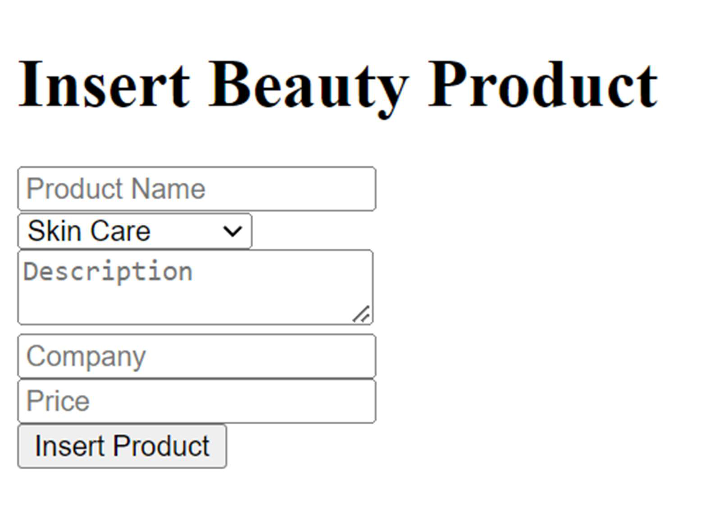

**update.php :-**

**<?php**   
**include 'db.php';**

**if ($_SERVER["REQUEST_METHOD"] == "POST") {**   
 **$product_id = $_POST['product_id'];**   
 **$name = $_POST['name'];**   
 **$category = $_POST['category'];**   
 **$descripon = $_POST['descripon'];**   
 **$company = $_POST['company'];**   
 **$price = $_POST['price'];**

**$sql = "UPDATE products SET name=?, category=?, descripon=?, company=?, price=?**

**WHERE product_id=?";**   
 **$stmt = $conn->prepare($sql);**   
 **$stmt->execute([$name, $category, $descripon, $company, $price, $product_id]);**

13

|  |  |  |
| --- | --- | --- |
| Tybca Sem-5 Div-2 | Web Framwork Services | Roll no :- 000 |

**echo "Product updated successfully!";**   
**}**   
**?>**

**<!DOCTYPE html>**   
**<html lang="en">**   
**<head>**   
  **<meta charset="UTF-8">**   
  **<tle>Update Product</tle>**   
**</head>**   
**<body>**   
  **<h1>Update Beauty Product</h1>**   
  **<form method="POST" acon="">**   
  **<input type="number" name="product_id" placeholder="Product ID" required><br>**   **<input type="text" name="name" placeholder="Product Name" required><br>**   **<select name="category" required>**   
  **<opon value="Skin Care">Skin Care</opon>**   
  **<opon value="Make-up">Make-up</opon>**   
  **<opon value="Hair Care">Hair Care</opon>**   
  **<opon value="Daily Essenal">Daily Essenal</opon>**   
  **<opon value="Fragrances">Fragrances</opon>**   
  **</select><br>**   
  **<textarea name="descripon" placeholder="Descripon"></textarea><br>**   
  **<input type="text" name="company" placeholder="Company"><br>**   
  **<input type="number" step="0.01" name="price" placeholder="Price" required><br>**   **<input type="submit" value="Update Product">**   
  **</form>**   
**</body>**

14

|  |  |  |
| --- | --- | --- |
| Tybca Sem-5 Div-2 | Web Framwork Services | Roll no :- 000 |

**</html>**

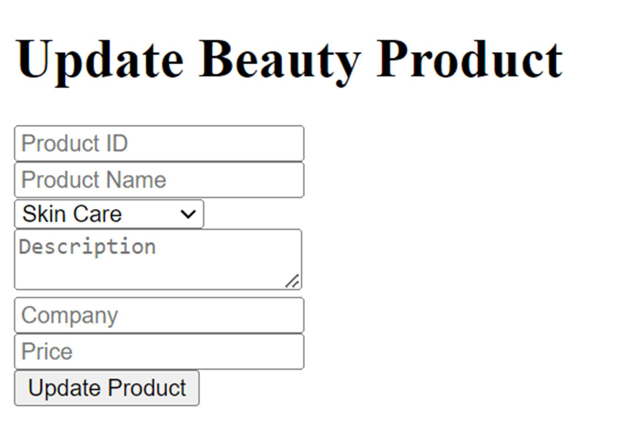

**Search.php :-**

**<?php**

**include 'db.php';**

**$products = [];**

**if (isset($_GET['category'])) {**

**$category = $_GET['category'];**

**$sql = "SELECT * FROM products WHERE category=?";**

**$stmt = $conn->prepare($sql);**

**$stmt->execute([$category]);**

**$products = $stmt->fetchAll(PDO::FETCH_ASSOC);**

15

|  |  |  |
| --- | --- | --- |
| Tybca Sem-5 Div-2 | Web Framwork Services | Roll no :- 000 |

**}**   
**?>**

**<!DOCTYPE html>**   
**<html lang="en">**   
**<head>**   
  **<meta charset="UTF-8">**   
  **<tle>Search Products</tle>**   
**</head>**   
**<body>**   
  **<h1>Search Beauty Products by Category</h1>**   
  **<form method="GET" acon="">**   
  **<select name="category" required>**   
  **<opon value="Skin Care">Skin Care</opon>**   
  **<opon value="Make-up">Make-up</opon>**   
  **<opon value="Hair Care">Hair Care</opon>**   
  **<opon value="Daily Essenal">Daily Essenal</opon>**   **<opon value="Fragrances">Fragrances</opon>**   
  **</select>**   
  **<input type="submit" value="Search">**   
  **</form>**

**<?php if ($products): ?>**   
  **<h2>Products Found:</h2>**   
  **<ul>**   
  **<?php foreach ($products as $product): ?>**   
  **<li>**   
  **<strong><?php echo $product['name']; ?></strong> -**   **<?php echo $product['category']; ?> -**

16

|  |  |  |
| --- | --- | --- |
| Tybca Sem-5 Div-2 | Web Framwork Services | Roll no :- 000 |

**<?php echo $product['descripon']; ?> -**   **<?php echo $product['company']; ?> -**   **$<?php echo $product['price']; ?>**   
  **</li>**   
  **<?php endforeach; ?>**   
  **</ul>**   
  **<?php elseif (isset($_GET['category'])): ?>**   
  **<p>No products found in this category.</p>**   **<?php endif; ?>**   
**</body>**   
**</html>**

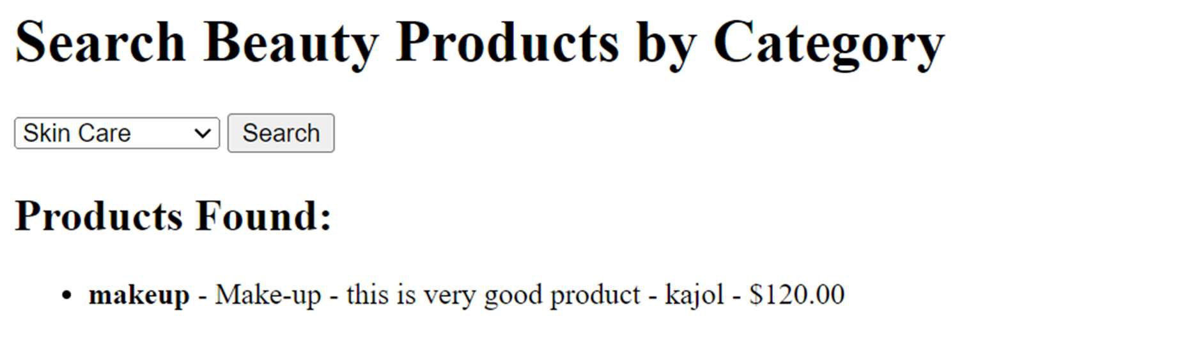

17

|  |  |  |
| --- | --- | --- |
| Tybca Sem-5 Div-2 | Web Framwork Services | Roll no :- 000 |

**6. Create web pages using PHP for Courier Company to help the operator to store courier informaon like booking id (Auto increment), name of the client, booking date, Client’s phone number, desnaon address and contact number, weight of the document and amount charged following facilies.**

• **Add courier informaon in the database**   
• **View all booking informaon** • **Delete the informaon based on booking id.**

• **Search courier details on the client’s contact number.**

**Index.php :-**

**<!DOCTYPE html>**   
**<html lang="en">**   
**<head>**   
  **<meta charset="UTF-8">**   
  **<meta name="viewport" content="width=device-width, inial-scale=1.0">**   **<tle>Courier Company</tle>**   
**</head>**   
**<body>**   
  **<h1>Courier Management System</h1>**   
  **<ul>**   
  **<li><a href="add.php">Add Courier Informaon</a></li>**   
  **<li><a href="view.php">View All Bookings</a></li>**   
  **<li><a href="delete.php">Delete Booking</a></li>**   
  **<li><a href="search.php">Search Booking by Phone</a></li>**   
  **</ul>**   
**</body>**   
**</html>**

18

|  |  |  |
| --- | --- | --- |
| Tybca Sem-5 Div-2 | Web Framwork Services | Roll no :- 000 |

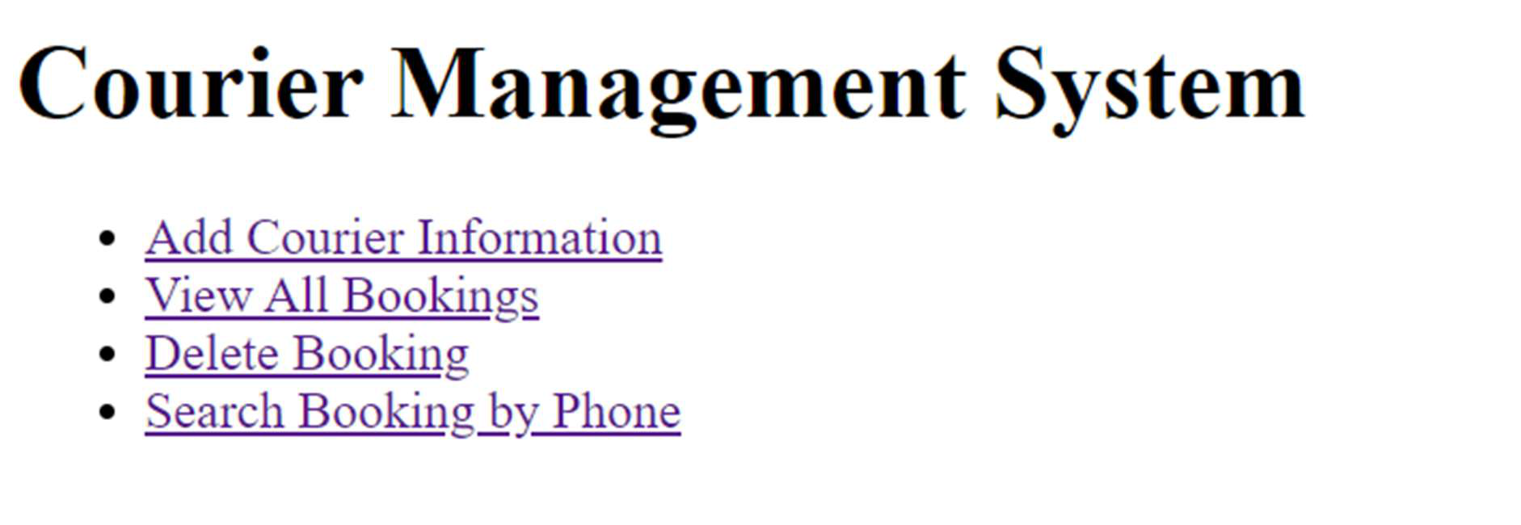

**Add.php :-**

**<?php**   
**include 'db.php';**

**if ($_SERVER["REQUEST_METHOD"] == "POST") { $name = $_POST['client_name'];**   
 **$phone = $_POST['client_phone'];**   
 **$address = $_POST['desnaon_address']; $dest_contact = $_POST['desnaon_contact']; $weight = $_POST['document_weight'];**   
 **$amount = $_POST['amount_charged'];**

**$stmt = $pdo->prepare("INSERT INTO bookings (client_name, client_phone,**   
**desnaon_address, desnaon_contact, document_weight, amount_charged) VALUES (?, ?, ?, ?, ?, ?)");**   
  **$stmt->execute([$name, $phone, $address, $dest_contact, $weight, $amount]);**

**echo "Courier informaon added successfully."; }**   
**?>**

19

|  |  |  |
| --- | --- | --- |
| Tybca Sem-5 Div-2 | Web Framwork Services | Roll no :- 000 |

**<form method="post" acon="">**   
  **Name: <input type="text" name="client_name" required><br>**   
  **Phone: <input type="text" name="client_phone" required><br>**   
  **Address: <input type="text" name="desnaon_address" required><br>**   
  **Desnaon Contact: <input type="text" name="desnaon_contact" required><br>**   **Weight: <input type="number" step="0.01" name="document_weight" required><br>**   **Amount Charged: <input type="number" step="0.01" name="amount_charged" required><br>**   
  **<input type="submit" value="Add Courier">**   
**</form>**

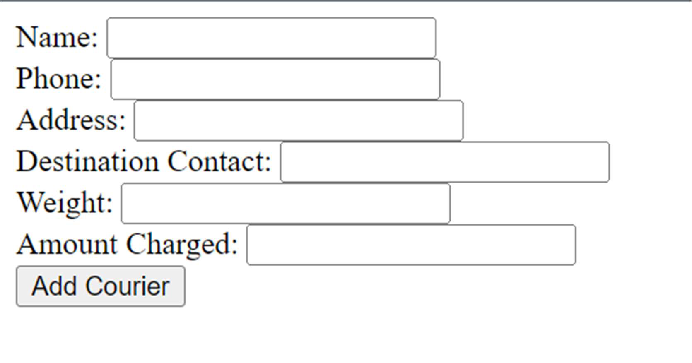

**View.php :-**

**<?php**   
**include 'db.php';**

**$stmt = $pdo->query("SELECT * FROM bookings"); $bookings = $stmt->fetchAll();**

20

|  |  |  |
| --- | --- | --- |
| Tybca Sem-5 Div-2 | Web Framwork Services | Roll no :- 000 |

**if ($bookings): ?>**   
  **<table border="1">**   
  **<tr>**   
  **<th>Booking ID</th>**   
  **<th>Client Name</th>**   
  **<th>Booking Date</th>**   
  **<th>Client Phone</th>**   
  **<th>Desnaon Address</th>**   
  **<th>Desnaon Contact</th>**   
  **<th>Document Weight</th>**   
  **<th>Amount Charged</th>**   
  **</tr>**   
  **<?php foreach ($bookings as $booking): ?>**   
  **<tr>**   
  **<td><?php echo $booking['booking_id']; ?></td>**   
  **<td><?php echo $booking['client_name']; ?></td>**   
  **<td><?php echo $booking['booking_date']; ?></td>**   **<td><?php echo $booking['client_phone']; ?></td>**   
  **<td><?php echo $booking['desnaon_address']; ?></td>**   **<td><?php echo $booking['desnaon_contact']; ?></td>**   **<td><?php echo $booking['document_weight']; ?></td>**   **<td><?php echo $booking['amount_charged']; ?></td>**   **</tr>**   
  **<?php endforeach; ?>**   
  **</table>**   
**<?php else: ?>**   
  **<p>No bookings found.</p>**   
**<?php endif; ?>**

21

|  |  |  |
| --- | --- | --- |
| Tybca Sem-5 Div-2 | Web Framwork Services | Roll no :- 000 |

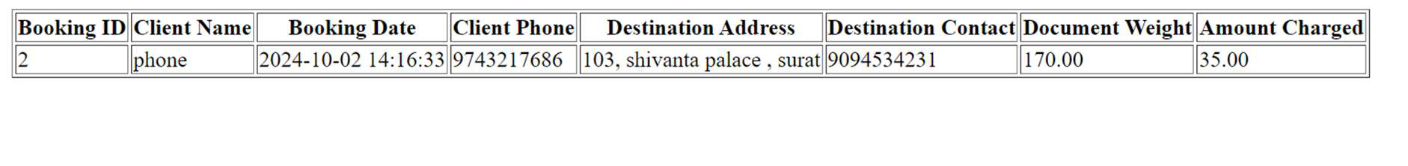

**Search.php :-**

**<?php**   
**include 'db.php';**

**$bookings = [];**

**if ($_SERVER["REQUEST_METHOD"] == "POST") {**   
  **$client_phone = $_POST['client_phone'];**

**$stmt = $pdo->prepare("SELECT * FROM bookings WHERE client_phone = ?");**   **$stmt->execute([$client_phone]);**   
  **$bookings = $stmt->fetchAll();**   
**}**   
**?>**

**<form method="post" acon="">**   
  **Client Phone: <input type="text" name="client_phone" required><br>**   **<input type="submit" value="Search">**   
**</form>**

**<?php if ($bookings): ?>**   
  **<table border="1">**   
  **<tr>**   
  **<th>Booking ID</th>**   
  **<th>Client Name</th>**

22

|  |  |  |
| --- | --- | --- |
| Tybca Sem-5 Div-2 | Web Framwork Services | Roll no :- 000 |

**<th>Booking Date</th>**   
  **<th>Client Phone</th>**   
  **<th>Desnaon Address</th>**   
  **<th>Desnaon Contact</th>**   
  **<th>Document Weight</th>**   
  **<th>Amount Charged</th>**   
  **</tr>**   
  **<?php foreach ($bookings as $booking): ?>**   
  **<tr>**   
  **<td><?php echo $booking['booking_id']; ?></td>**   
  **<td><?php echo $booking['client_name']; ?></td>**   
  **<td><?php echo $booking['booking_date']; ?></td>**   **<td><?php echo $booking['client_phone']; ?></td>**   
  **<td><?php echo $booking['desnaon_address']; ?></td>**   **<td><?php echo $booking['desnaon_contact']; ?></td>**   **<td><?php echo $booking['document_weight']; ?></td>**   **<td><?php echo $booking['amount_charged']; ?></td>**   **</tr>**   
  **<?php endforeach; ?>**   
  **</table>**   
**<?php else: ?>**   
  **<p>No bookings found for this phone number.</p>**   
**<?php endif; ?>**

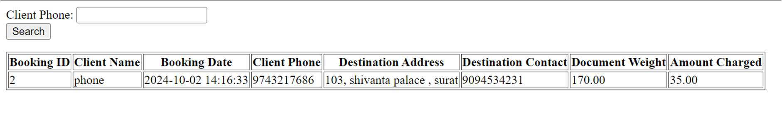

23

|  |  |  |
| --- | --- | --- |
| Tybca Sem-5 Div-2 | Web Framwork Services | Roll no :- 000 |

**Delete.php :-**

**<?php**   
**include 'db.php';**

**if ($_SERVER["REQUEST_METHOD"] == "POST") {**   
  **$booking_id = $_POST['booking_id'];**

**$stmt = $pdo->prepare("DELETE FROM bookings WHERE booking_id = ?"); $stmt->execute([$booking_id]);**

**echo "Booking ID $booking_id deleted successfully."; }**   
**?>**

**<form method="post" acon="">**   
  **Booking ID to delete: <input type="number" name="booking_id" required><br>**   **<input type="submit" value="Delete Booking">**   
**</form>**

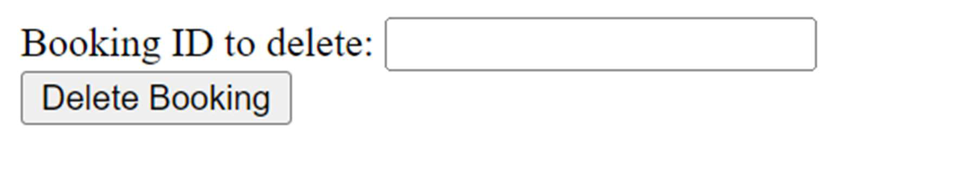

24